**Assignment No. 1 B**

**Program Code:**

index.js

const express = require('express');

const app = express();

app.use(express.json());

var data = {

firstName: "",

lastName:""

}

app.get('/', function(req, res){

res.sendFile(__dirname+"/");

});

app.post("/", (req, res) => {

const userData = req.body

data = userData;

// console.log(data)

res.status(200).json(data);

});

app.listen(3000);

index.html

<!doctype html>

<html lang="en">

<head>

<!-- Required meta tags -->

<meta charset="utf-8">

<meta name="viewport" content="width=device-width, initial-scale=1">

<!-- Bootstrap CSS -->

<script src="https://ajax.googleapis.com/ajax/libs/jquery/3.6.3/jquery.min.js"></script>

<link href="https://cdn.jsdelivr.net/npm/bootstrap@5.0.2/dist/css/bootstrap.min.css" rel="stylesheet"

integrity="sha384-EVSTQN3/azprG1Anm3QDgpJLIm9Nao0Yz1ztcQTwFspd3yD65VohhpuuCOmLASjC" crossorigin="anonymous">

<title>Assignment 1B</title>

</head>

<body>

<div class="container">

<div class="row">

<form class="col-4 mx-auto pt-5">

<h1 class="text-center">Assignment 1B</h1><br><br>

<div class="mb-3">

<label for="exampleInputText" class="form-label">First Name</label>

<input type="text" class="form-control" id="exampleInputText" aria-describedby="name" name="fname">

</div>

<div class="mb-3">

<label for="exampleInputText2" class="form-label">Last Name</label>

<input type="text" class="form-control" id="exampleInputText2" aria-describedby="name" name="lname">

</div>

<button type="button" onclick="submitForm()" class="btn btn-primary">Submit</button>

<br><hr>

<small class="small text-success" id="h1tag"></small>

</form>

</div>

</div>

<script src="https://cdn.jsdelivr.net/npm/bootstrap@5.0.2/dist/js/bootstrap.bundle.min.js"

integrity="sha384-MrcW6ZMFYlzcLA8Nl+NtUVF0sA7MsXsP1UyJoMp4YLEuNSfAP+JcXn/tWtIaxVXM"

crossorigin="anonymous"></script>

</body>

<script>

function submitForm() {

var name = $('input[name=fname]').val();

var lname = $('input[name=lname]').val();

// console.log(name + lname);

$.ajax({

type: "POST",

url: 'http://localhost:3000/',

data: JSON.stringify({

name, lname

}),

contentType: "application/json; charset=utf-8",

traditional: true,

success: function (data) {

// console.log(data.name);

document.getElementById("h1tag").innerHTML = "Your full name is : " + data.name + " " + data.lname;

}

})

}

</script>

</html>

**Output:** Running server on localhost:3000 : http://localhost:3000/

Before ajax call:

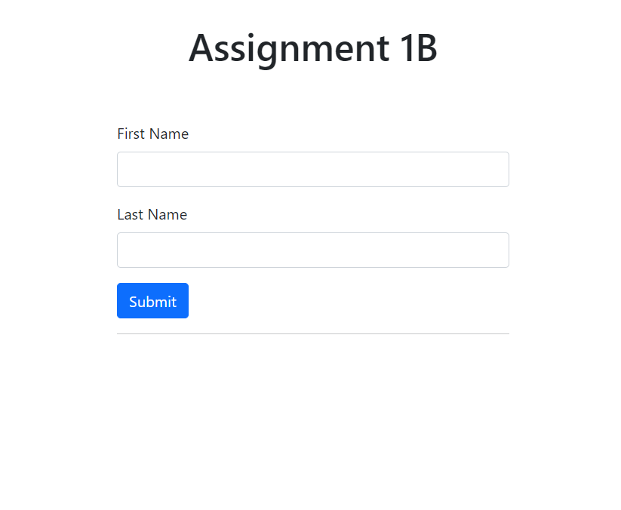

After Ajax call:

